# Using command line for Treasure Data

First of all, you need to download Treasure data toolbelt [link](https://toolbelt.treasuredata.com/) . Just download and install.

Some useful information can be find also [here](https://support.treasuredata.com/hc/en-us/articles/360001262207-Treasure-Workflow-Quick-Start-using-TD-Toolbelt-in-a-CLI).

Then go to start and type ***Treasure data command prompt (CLI)***. Now you need to login to TD through CLI. Just copy the following command and hit enter: **td -e https://api.eu01.treasuredata.com account -f** (you can copy with CTRL+C and paste to CLI with right click). If you will use other instance, then adjust the command accordingly. Then insert your credentials (see example below):

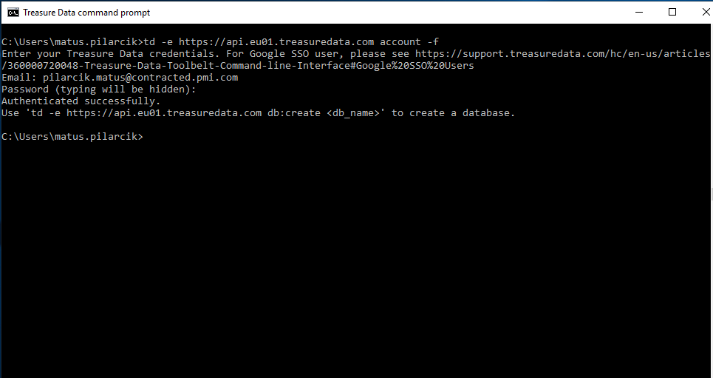

Now you are logged in. I usually change the working directory to the Desktop (you can change it to any folder you want). Change the directory is performed with the following command: **cd Desktop**

There are also other commands. After command **td help:all ,**youcan check what is possible to do with CLI for Treasure data.

If mainly used command **td wf download <project_name>** .

(for example **td wf download pr_load_from_ga** ).

If you would like to push back (to Treasure data) some project, change the directory into the folder, where are .dig files and .sql files for that project (cd <folder_name>) and use command **td wf push <pick the project name>**

There are also commands for creating connectors. But before that, you need to create .yml (configuration file). Then the command is:

**td connector:create tr_ga_session “” db_l0_ga_bi session session.yml** ,where

* tr_ga_session : is unique id of the connector (you can choose the name)
* “” is regarding scheduling and quotes means no scheduling
* db_l0_ga_bi : destination database, where data will be populated
* session : table name, where data will be populated
* session.yml : name of the configuration file in working directory.

**td connector:preview session.yml**

* this command will show you the preview of the data you will get.